Nursery
Topics I will learn in February 2017

English: Letters of the month: Z

Oral:
Recognition of letters - Z
- Phonic sounds of letters – Z
- Picture recognition and words related to Z

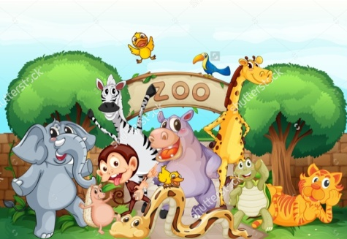
Z- Zebra Z– Zoo

Writing: (Tracing)
C – Curves, D – Curves, Alphabets (V , W , X)

Mathematics:

Oral:
Recognition of number 20
Writing: Tracing number 17 , 18

EVS:
Water
- Identification of the sources of water
( Rain, River, Pond, Lake, Well, Sea etc….. )

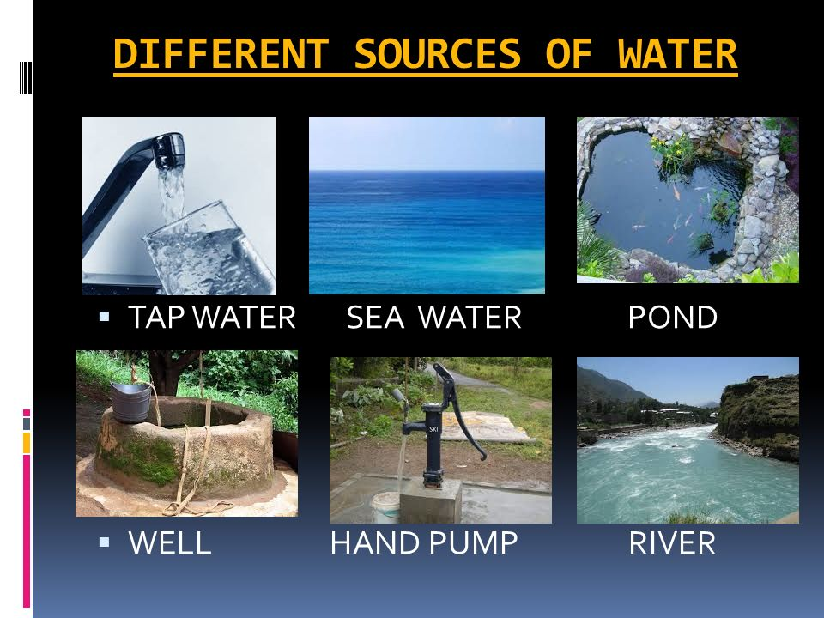

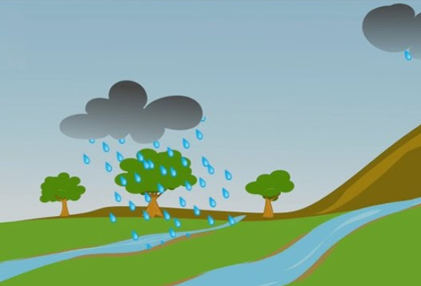

- Uses of water

Creative work of the month:
Water cycle with paper plate

Activity of the month
Activity on uses of water
Water play

Rhymes of the month:
1.Jack and Jill 2. Ding dong bell
3.Water water everywhere 4. Rain on the green grass

Jack and Jill
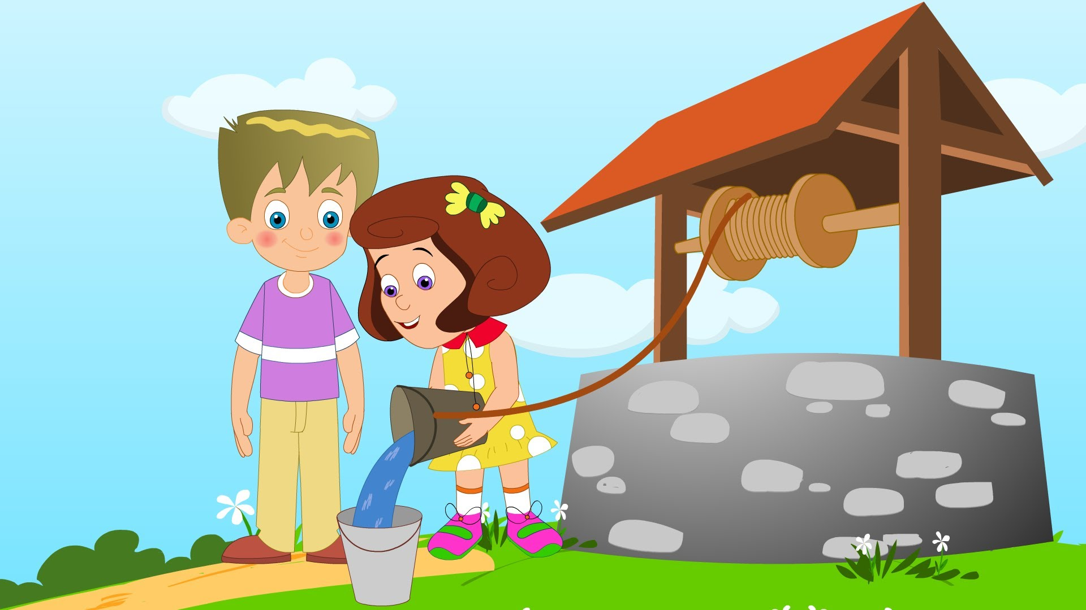
Jack and Jill went up the hill
To fetch a pail of water .
Jack fell down and broke his crown,
And Jill came tumbling after

Ding Dong Bell
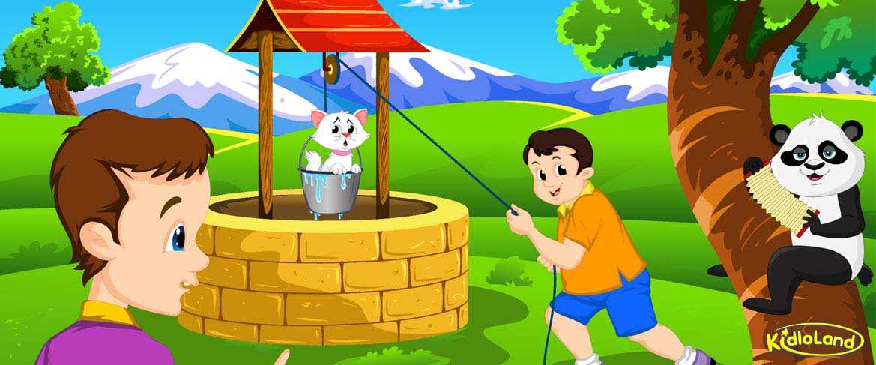
Ding, dong, bell,
Pussy’s in the well.
Who put her in?
Little Johnny Flynn.
Who pulled her out?
Little Tommy Stout.
What a naughty boy was that,
To try to drown poor pussy cat,
Who never did him any harm,
But killed all the mice in the farmer's barn.

Water Water Everywhere
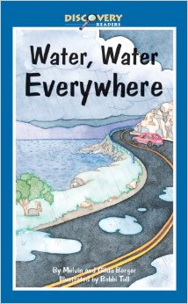
Water-water everywhere,
Waste no water anywhere,
Sow a seed and water it,
See a lovely plant grow, from it.
Wash your dirty clothes with it,
Clean and sparkling clothes are a hit.
Take a bath and you can sit,
Looking cheerful, bright and bit.

Rain on the Green Grass
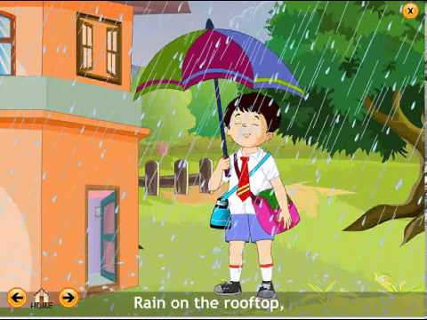
Rain on the green grass,
Rain on the tree,
Rain on the housetop,
But not on me.

