Nursery
Topics I will learn in March 2017

English:
Oral:
Revision: Alphabets A to Z with Picture recognition and Phonic sounds

Writing:
Tracing alphabets Y & Z

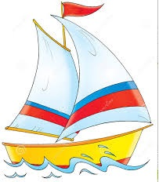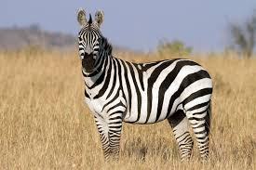
Y-Yacht Z-Zebra

Revision: C – Curves, D – Curves, Alphabets A to Z

Number Work:
Oral:
Revision: Numbers 1 to 20 with Object counting

Writing:
Tracing number 19 & 20
Revision: 1 to 20

EVS: Birds
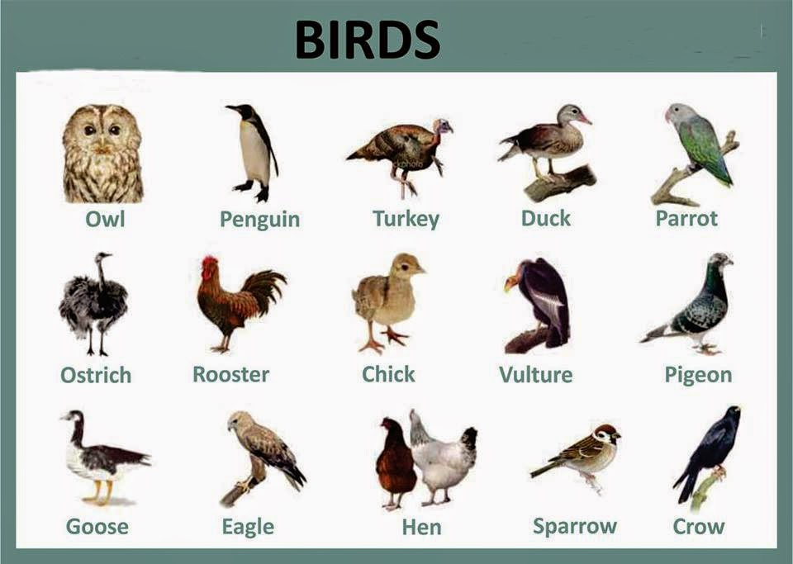

- Identification
- Special Characteristics
Revision:
- Animals
- Fruits
- Vegetables
- Seasons
- Community helpers
- Shapes
- Transport

Activity of the month:
Fancy Dress competition

Rhymes of the month:
.
- Five Little Ducks 2.Two Little Dicky Birds
- Cock A Doodle Doo 4. Goosey Gossey Gander

Five Little Ducks

Five little ducks
Went out one day
Over the hill and far away
Mother duck said
"Quack, quack, quack, quack."
But only four little ducks came back.
Four little ducks
Went out one day
Over the hill and far away
Mother duck said
"Quack, quack, quack, quack."
But only three little ducks came back.
Three little ducks
Went out one day
Over the hill and far away
Mother duck said
"Quack, quack, quack, quack."
But only two little ducks came back.
Two little ducks
Went out one day
Over the hill and far away
Mother duck said
"Quack, quack, quack, quack."
But only one little duck came back.
One little duck
Went out one day
Over the hill and far away
Mother duck said
"Quack, quack, quack, quack."
But none of the five little ducks came back.
Sad mother duck
Went out one day
Over the hill and far away
The sad mother duck said
"Quack, quack, quack."
And all of the five little ducks came back.

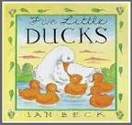

Cock A Doodle Doo
Cock a doodle do!
My dame has lost her shoe,
My master's lost his fiddlestick,
And knows not what to do
Goosey Gossey Gander
Goosey goosey gander,
Whither shall I wander?
Upstairs and downstairs
And in my lady's chamber.
There I met an old man
Who wouldn't say his prayers,
So I took him by his left leg
And threw him down the stairs.

Two Little Dicky Birds
Two little dicky birds sitting on a wall
One named Peter, one named Paul.
Fly away Peter! Fly away Paul!
Come back Peter! Come back Paul!

