MOUNT LITERA ZEE SCHOOL, EAST BANGALORE

MATH

I. Solve the following:

1. 56 2. 45 3 . 50 4 . 27 5 . 72
× 3 × 9 × 6 × 6 × 4

6. 125 7. 603 8 . 713 9 . 624 10.925
× 2 × 9 × 5 × 4 ×

ii. Divide the following:

1. 90÷ 5=
2. 54÷ 2=
3. 27÷ 3=
4. 45÷ 5=
5. 36÷ 6=
6. 84 ÷ 6=
7. 90 ÷10=
8. 72÷ 3=
9. 12÷3=
10. 48÷ 4=

English: Write a story based on the given pictures about 5 to 8 sentences with a moral and a title.

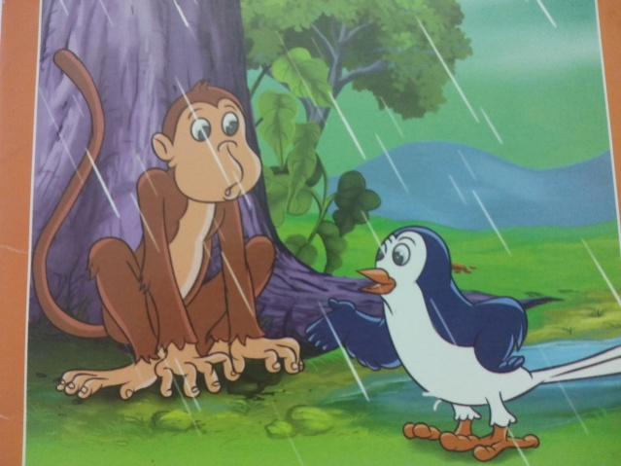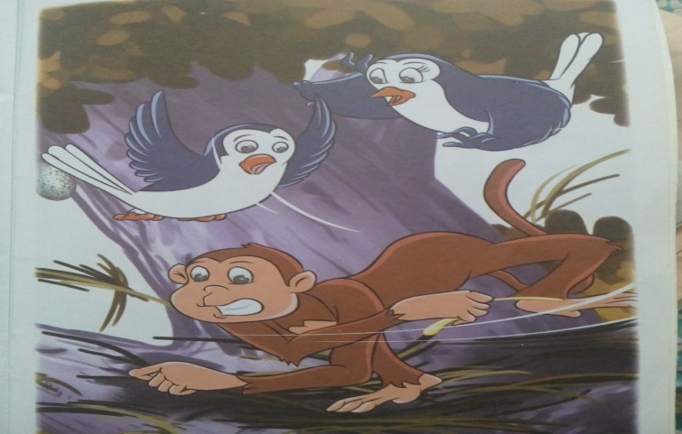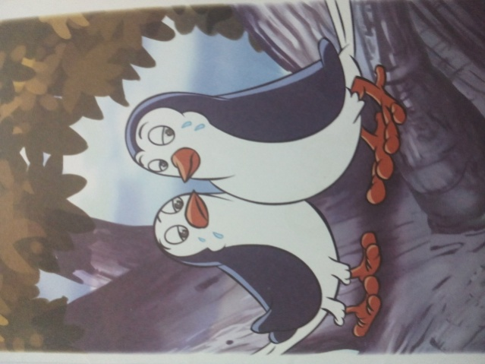

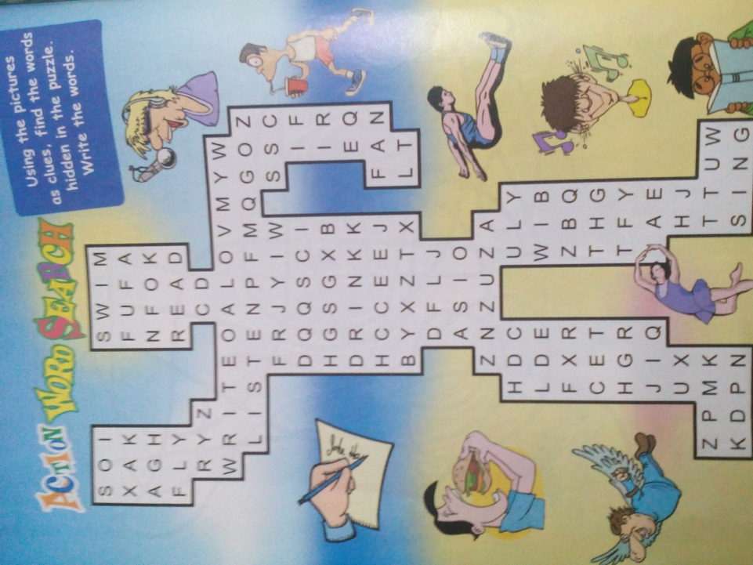
Find the action words hidden in the puzzle.

